Software Testing Documentation Report
Project: AI Crop Disease Diagnosis System – Smart Crop Health API
Testing Focus: Backend API Testing using Pytest

1. Introduction
This document presents the testing performed on the AI Crop Disease Diagnosis System backend. The objective of the testing process is to verify that individual modules work correctly, that different modules interact properly with each other, and that the complete system functions as expected in real-world scenarios. The testing process includes Unit Testing, Integration Testing, End-to-End (E2E) Testing, and Regression Testing to ensure system stability after updates or bug fixes.

2. Unit Testing
Unit testing verifies the correctness of individual modules and functions within the system. These tests ensure that each component performs its intended functionality independently.
Command Used:
python -m pytest tests/test_validators.py tests/test_cost_service.py tests/test_ml_modules.py tests/test_image_quality.py -v --tb=short
Modules Tested:
- Validators module
- Cost service module
- Machine learning utilities
- Image quality validation

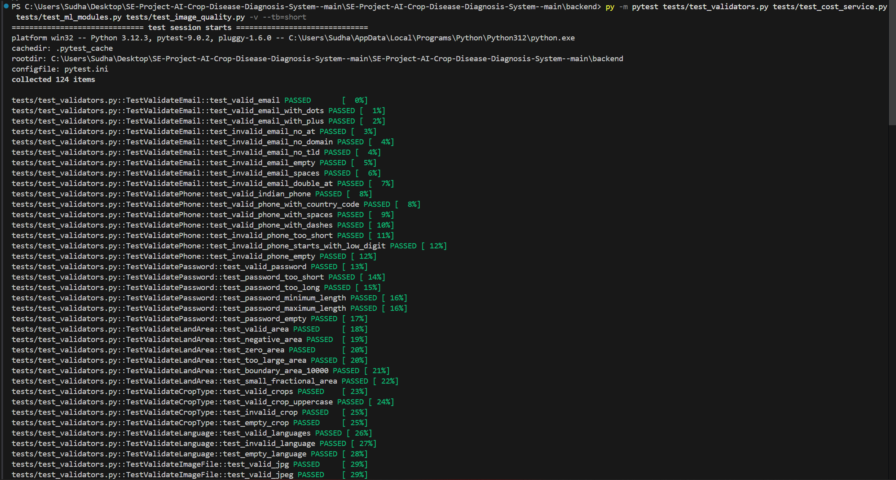
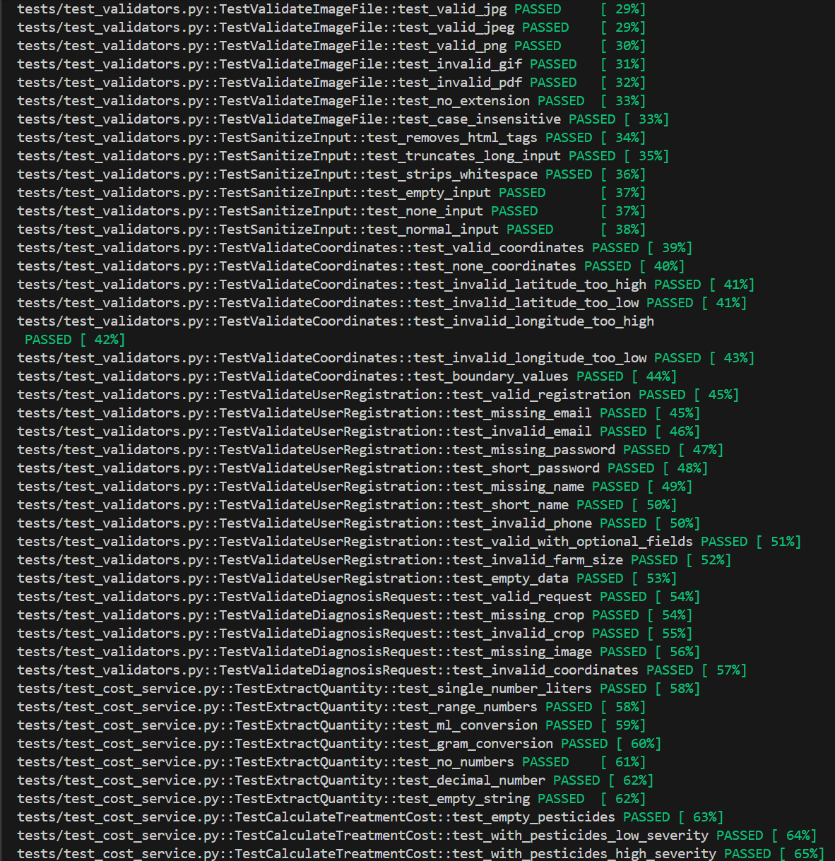
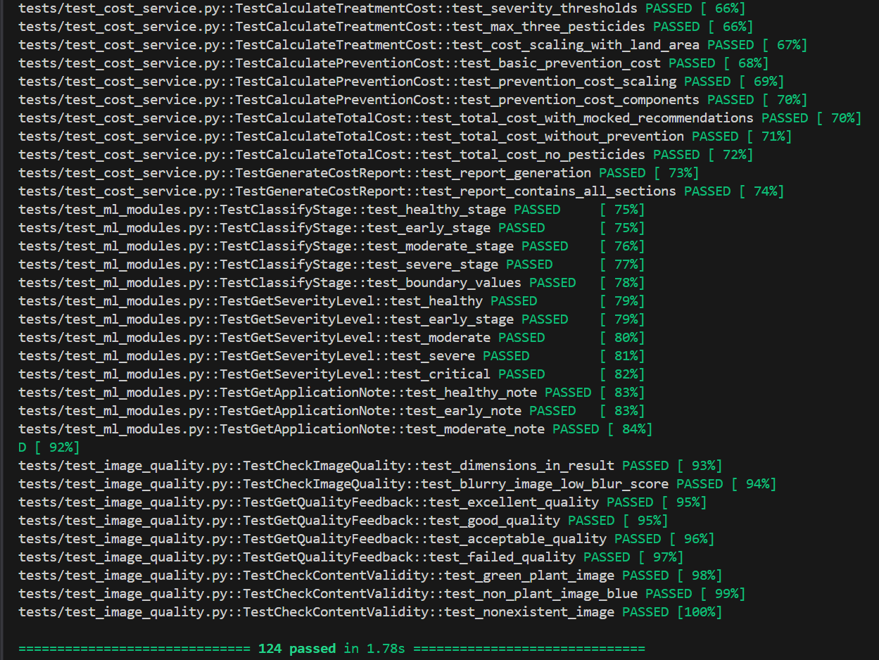
Conclusion: The unit tests confirm that individual components such as validation logic, ML utilities, and cost calculation modules function correctly.

3. Integration Testing
Integration testing verifies the interaction between multiple modules. This ensures that API routes, validators, and service modules work together correctly.
Command Used:
python -m pytest tests/test_integration.py -v --tb=short
Modules Interacting:
- API routes
- Validation modules
- Database interaction layer
- Service modules
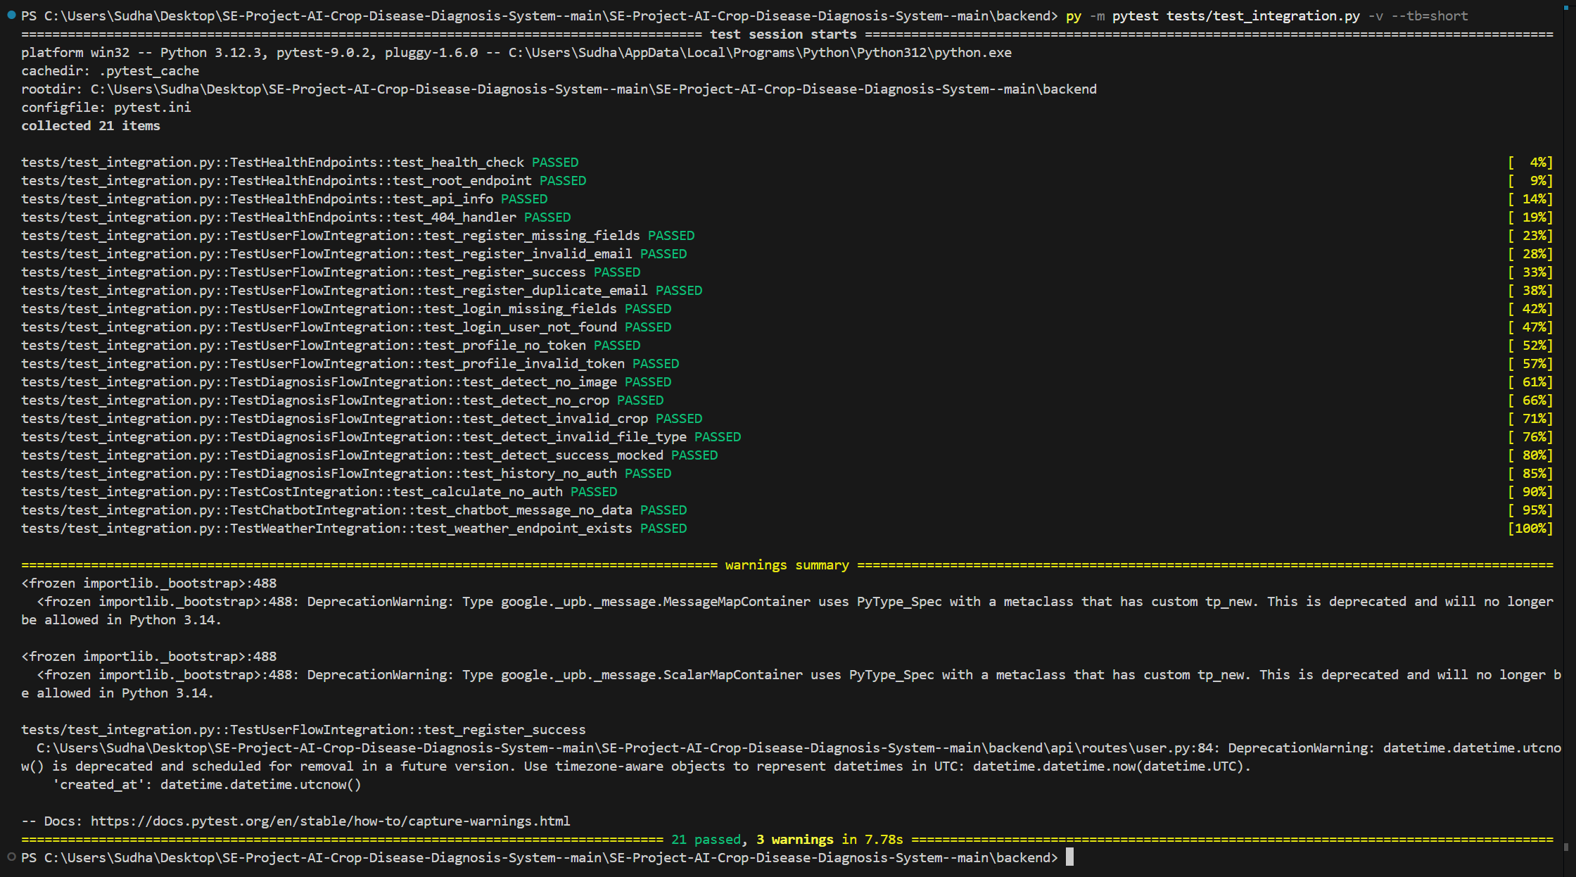
Conclusion: Integration tests confirm that multiple components interact properly and the API endpoints process requests correctly.

4. End-to-End (E2E) Testing
End-to-End testing validates complete workflows from user input to system output. This simulates real user interactions with the application.
Command Used:
python -m pytest tests/test_e2e.py -v --tb=short
Workflows Tested:
- System health check
- User registration and login
- Crop disease diagnosis process
- Input validation and error handling
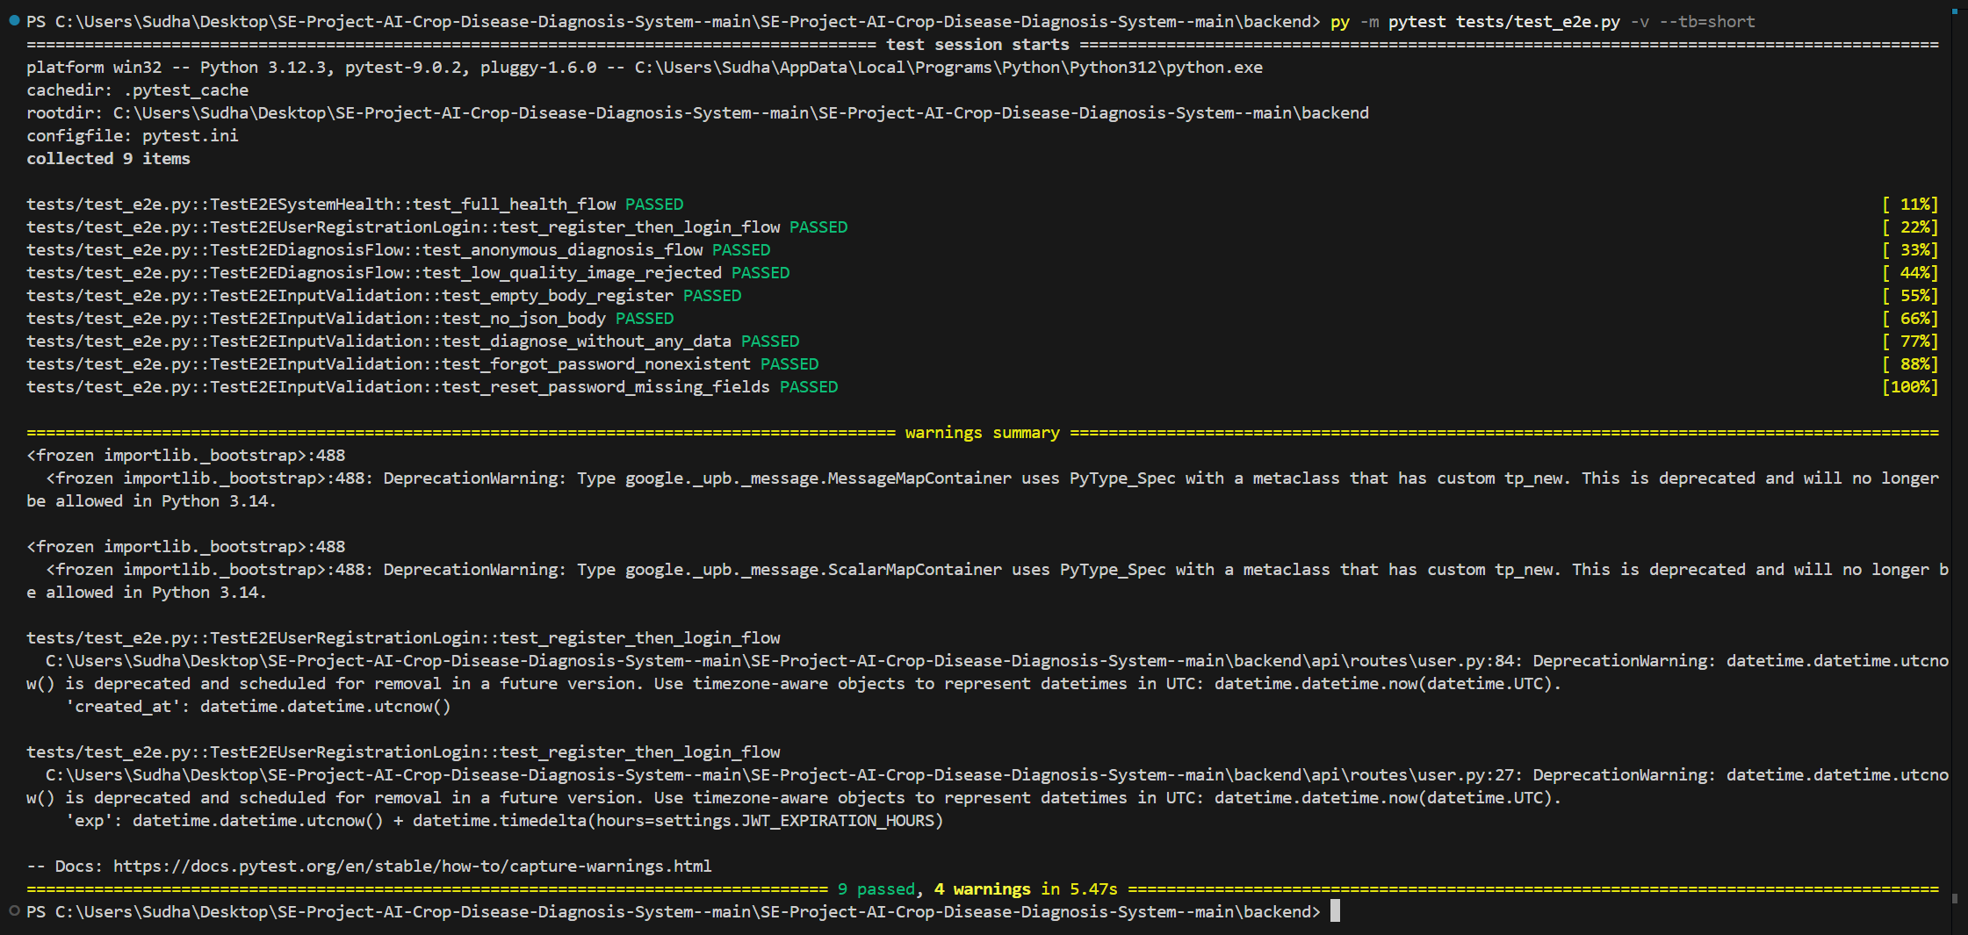
Conclusion: End-to-End tests confirm that the full application workflow operates correctly from user interaction to final system output.

5. Full Test Suite Execution
The entire test suite was executed together to ensure that all tests pass without conflicts and that the system remains stable when all modules are tested collectively.
Command Used:
python -m pytest tests/ -v --tb=short
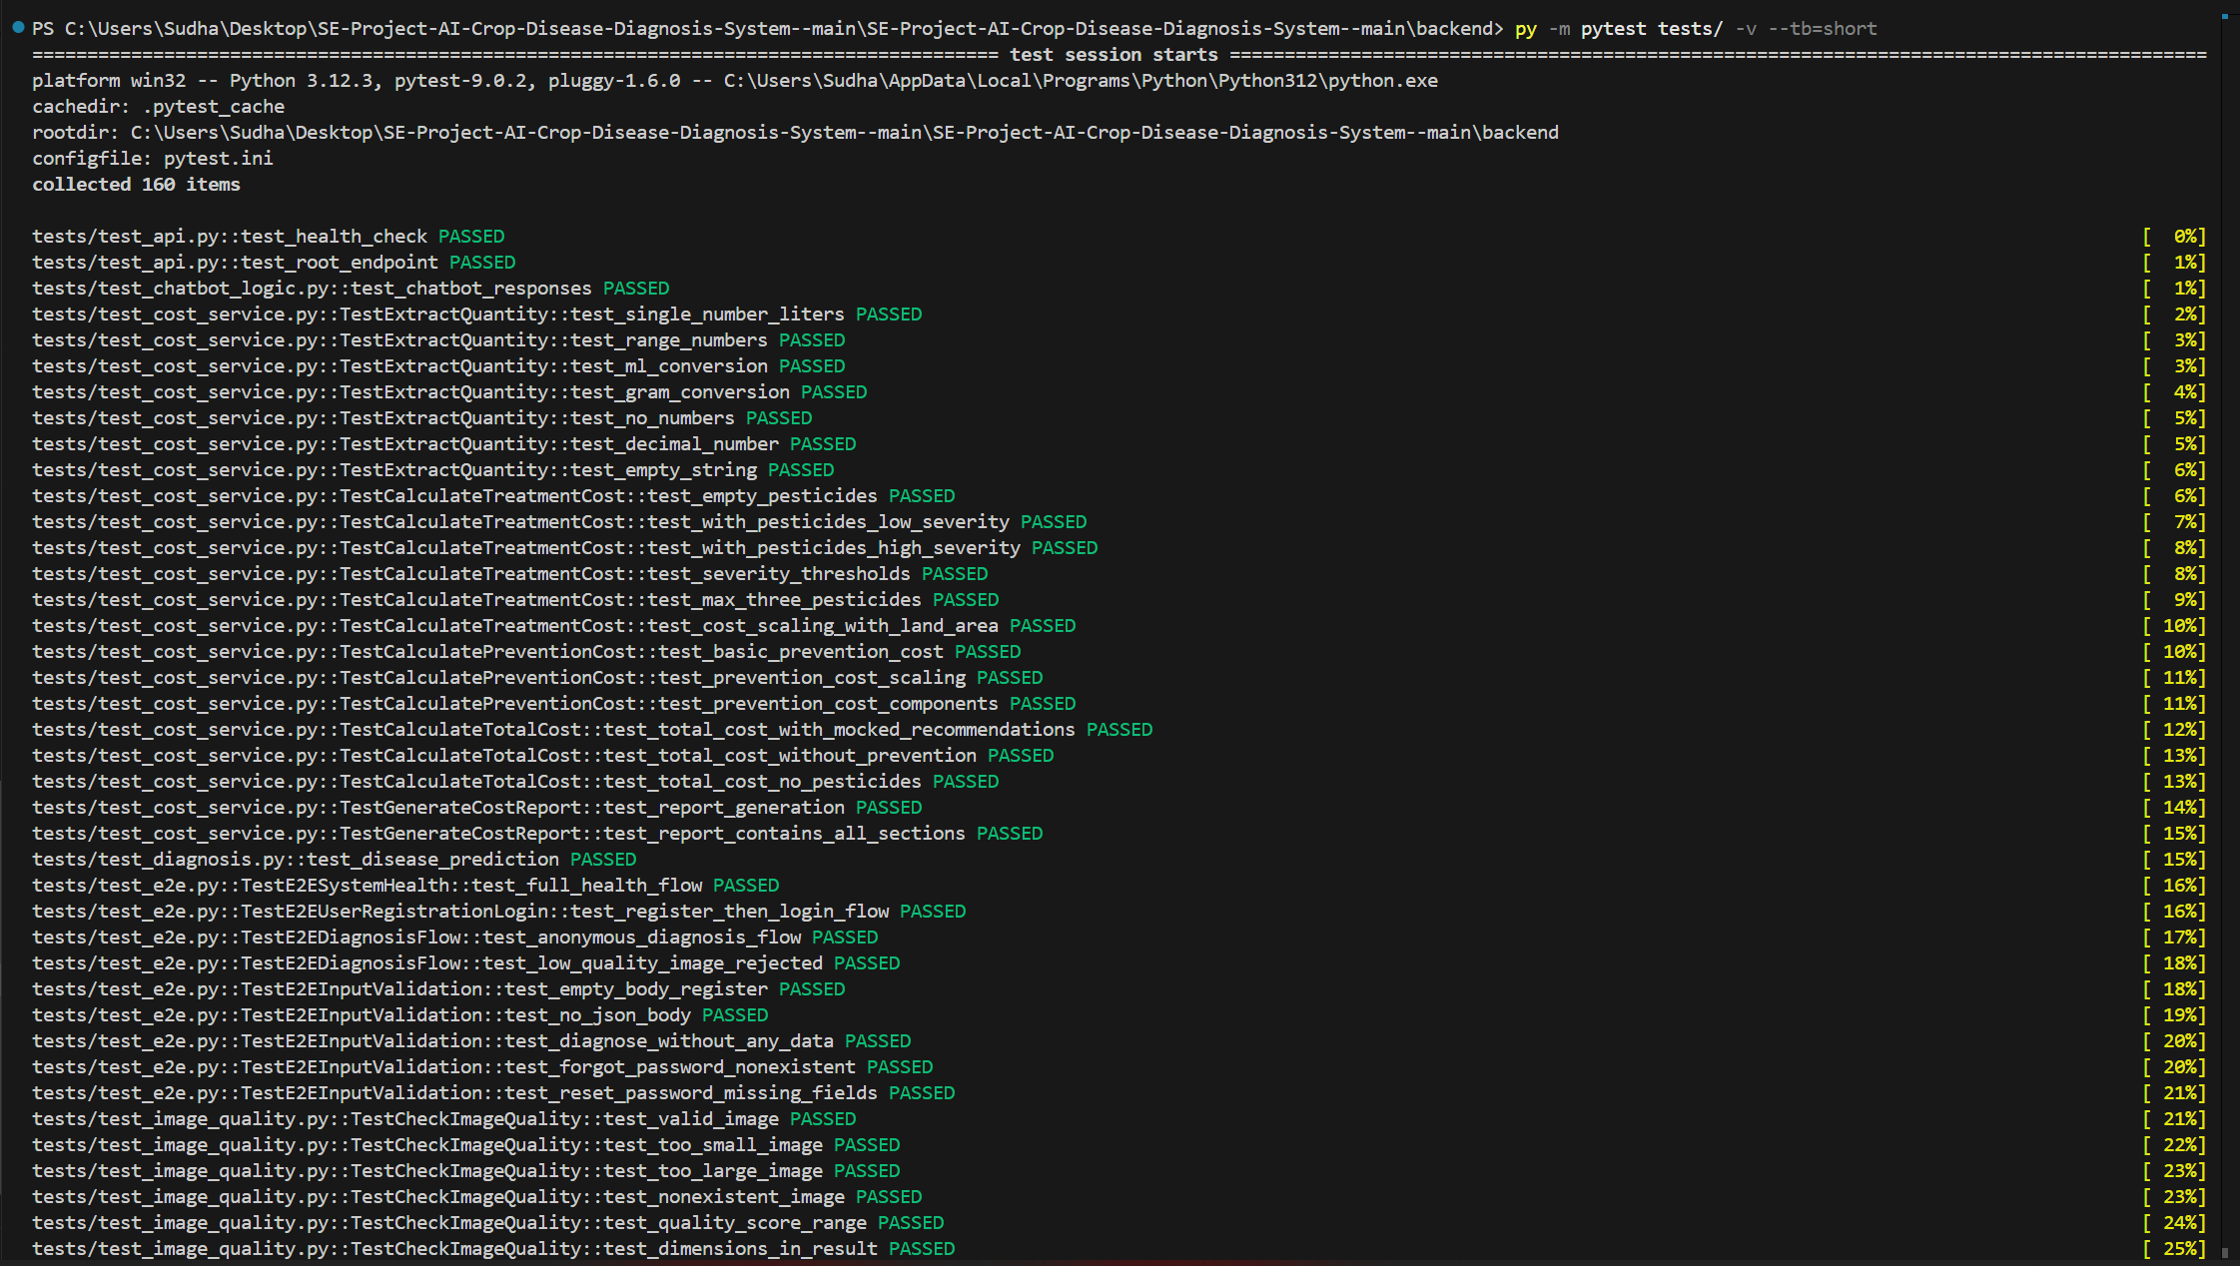
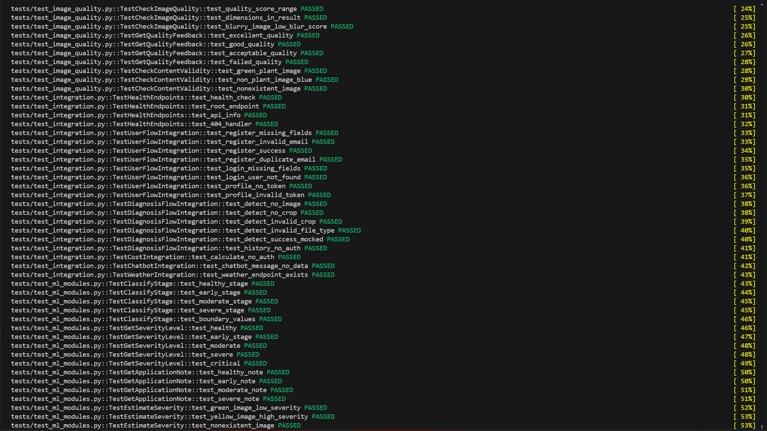
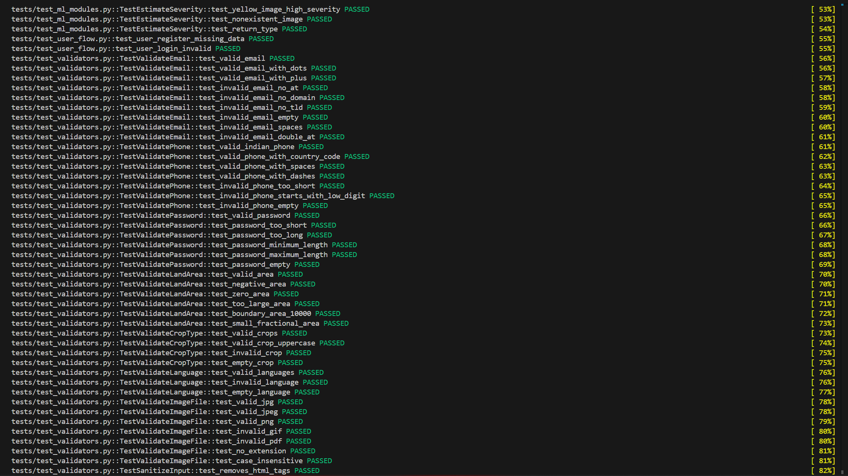
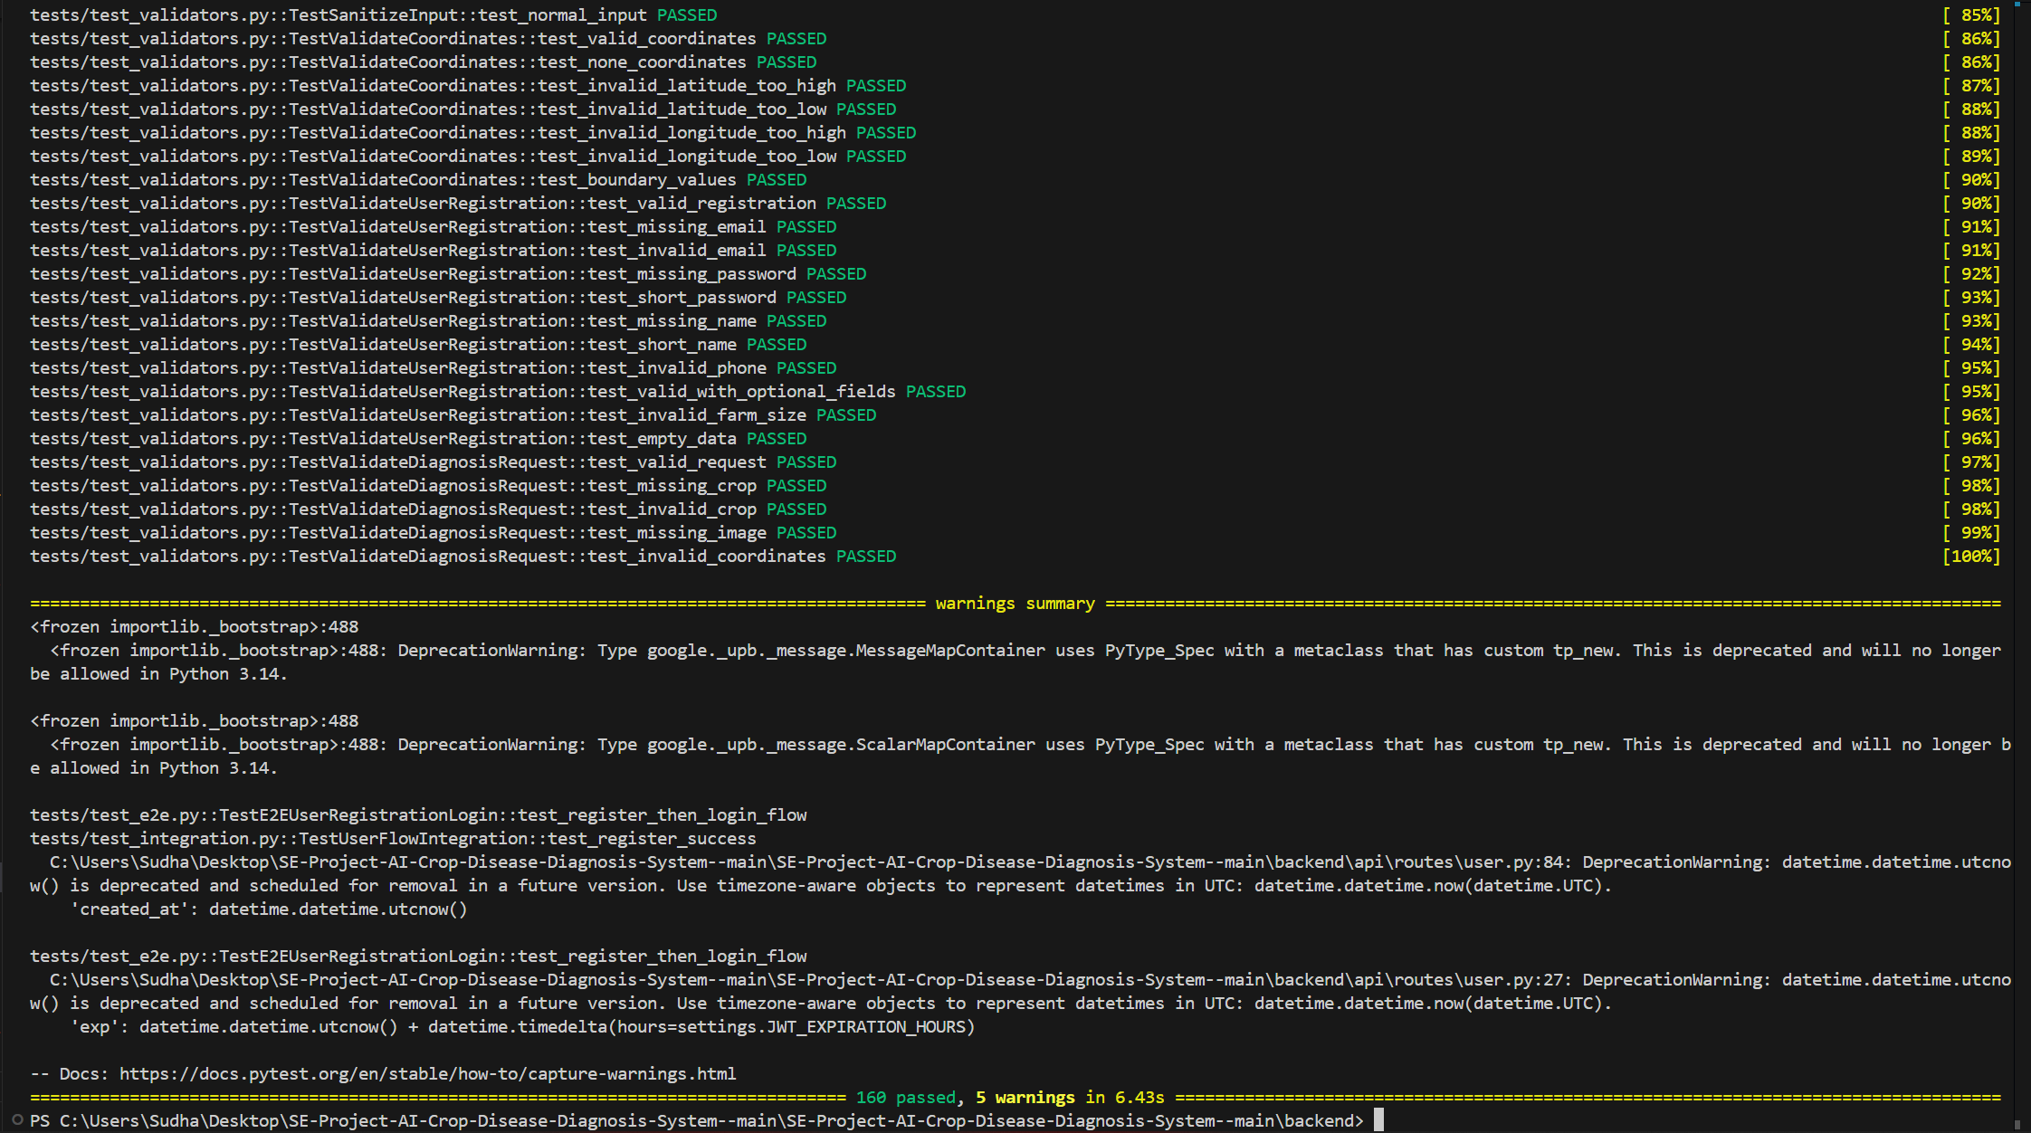
Conclusion: The complete test suite execution verifies that the system is stable and all modules function correctly together.

6. Regression Testing

Regression Testing
Regression testing ensures that previously fixed bugs remain resolved and that existing system functionality is not broken by new code changes. These tests protect critical system behavior such as API response structures, input validation boundaries, and security sanitization.
Command Used:

python -m pytest tests/test_regression.py -v --tb=short

Test Coverage:
- Known bug fixes verification
- Validator boundary conditions
- API response structure consistency
- Diagnosis pipeline output structure
- Input sanitization security checks
- Image upload validation rules
Workflows Tested:
- Cost route accepts correct diagnosis ID type
- User registration response format remains stable
- Login endpoint returns valid JWT token
- Email, password, coordinate, crop, and language validations remain unchanged
- Diagnosis API always returns prediction, pesticide recommendations, and image quality
- Dangerous file types (.exe, .bat, .php) are rejected during image upload
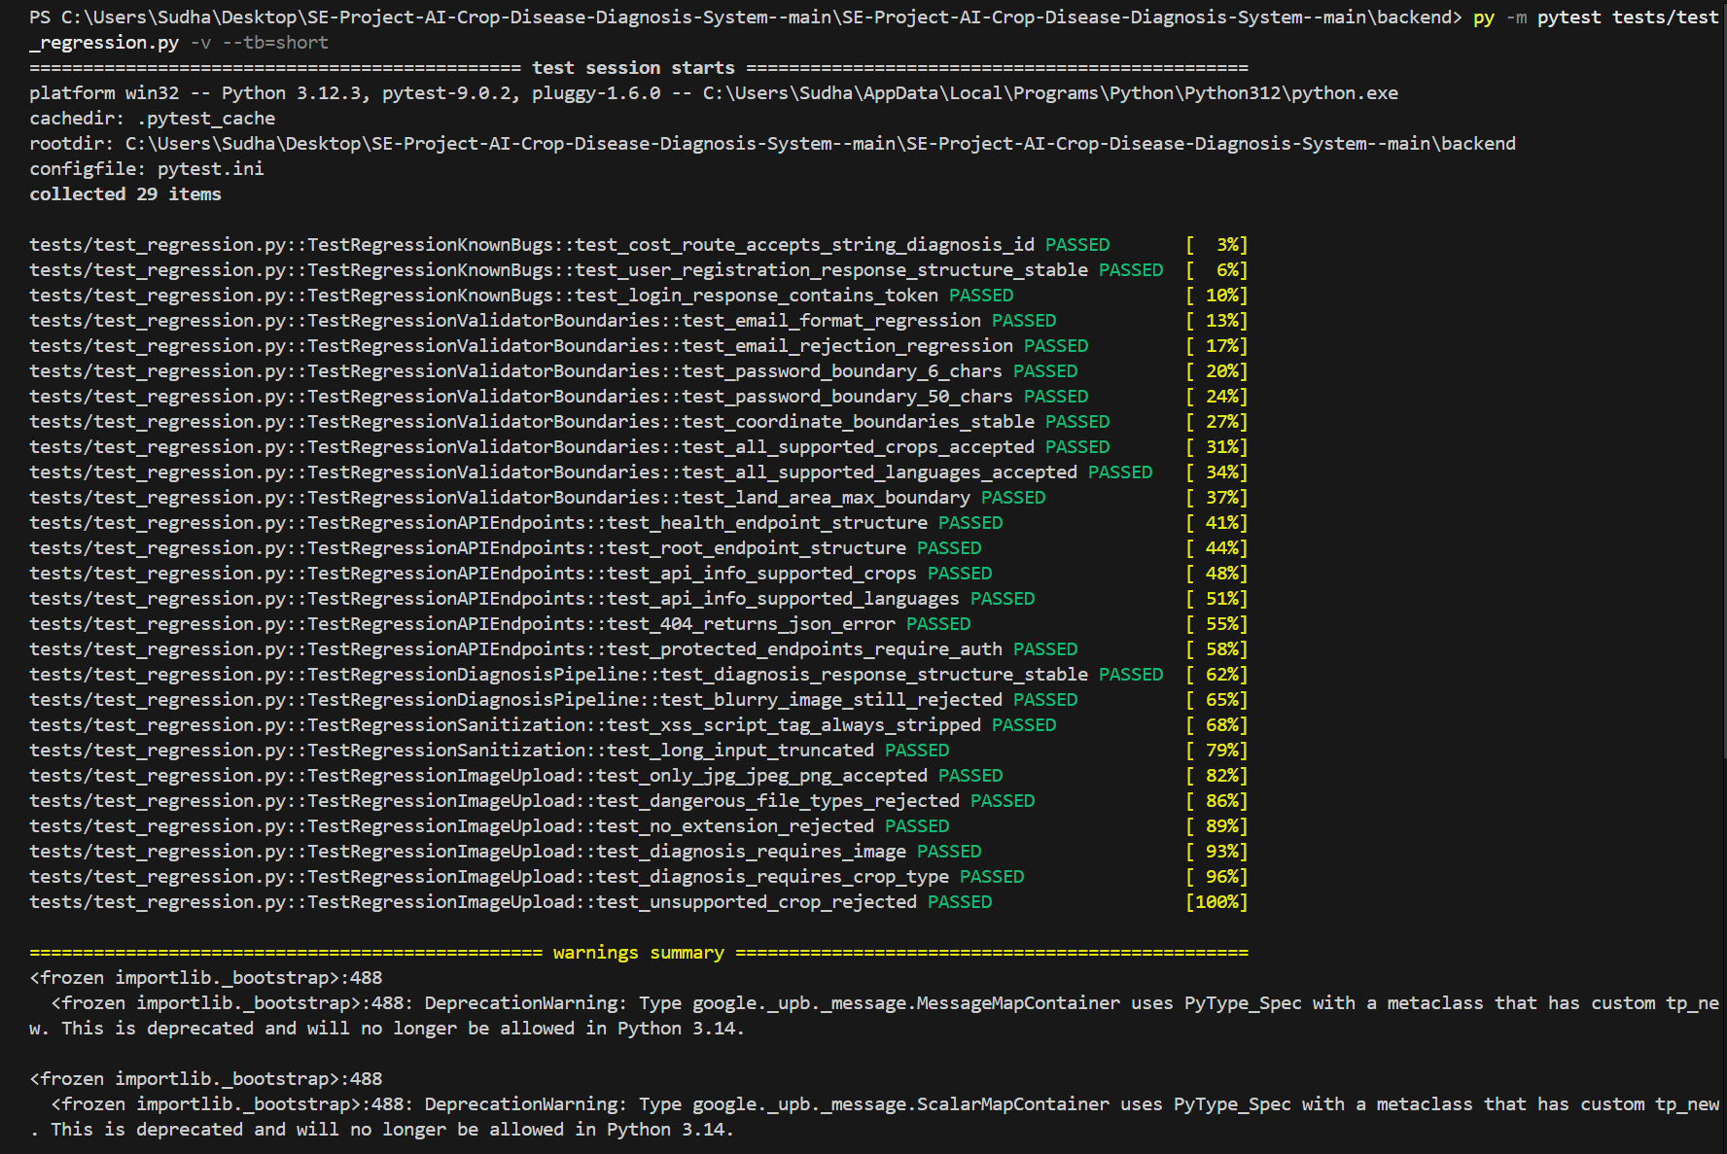
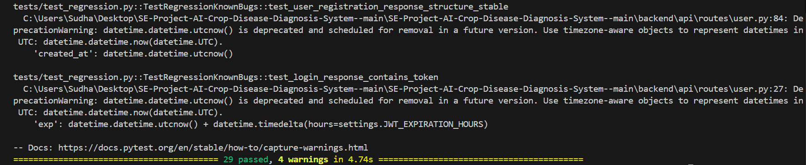
Conclusion:
Regression testing confirms that previously identified issues remain fixed and that system behavior remains stable after recent code modifications.

7. Test Result Summary
Test Type | Result
Unit Testing | Passed
Integration Testing | Passed
End-to-End Testing | Passed
Full Test Suite | Passed
Regression Testing | Passed

8. Final Conclusion
The testing results confirm that the AI Crop Disease Diagnosis System backend functions correctly. Unit tests validated the functionality of individual components, integration tests confirmed proper interaction between modules, and end-to-end tests verified complete user workflows. In addition, regression testing ensured that previously fixed bugs remained resolved and that critical system behaviors remained stable after code changes. All tests passed successfully, indicating that the system is reliable, stable, and ready for deployment.

